Changes to following file:

# **1.index.html**

## Line 105 to 108:

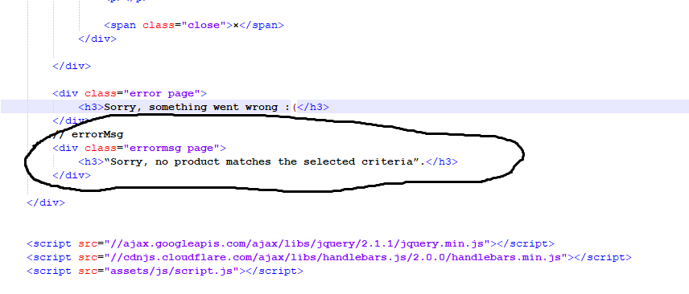

# **2. style.css**

## Line 105 to 120:

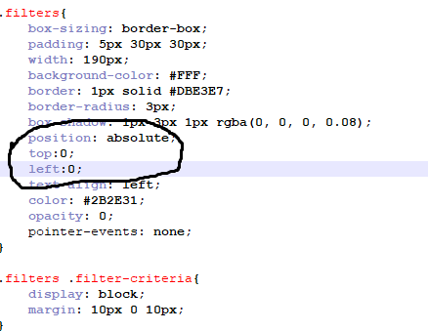

## Line 75 to 81:

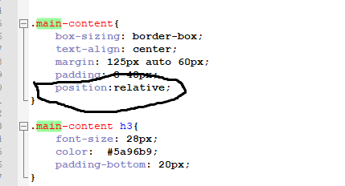

## Line 204 to 207:

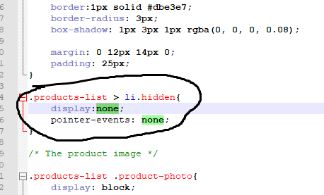

## Line 404 to 422:

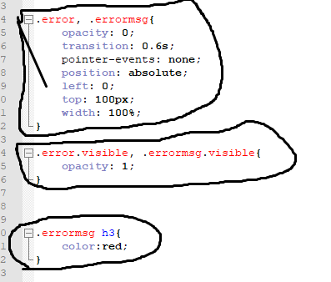

# **3.script.js**

## Line 342 to 346:

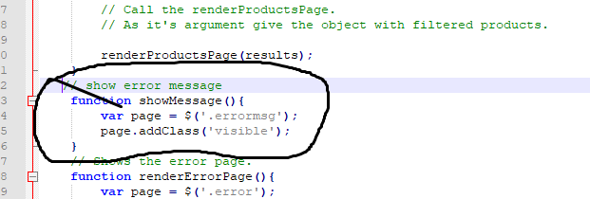

## Line 219 to 222

